Map Viewer
An easy way to view and access maps and data.
Optimized for non-professionals that need a simple and easy way to access maps and geospatial content.

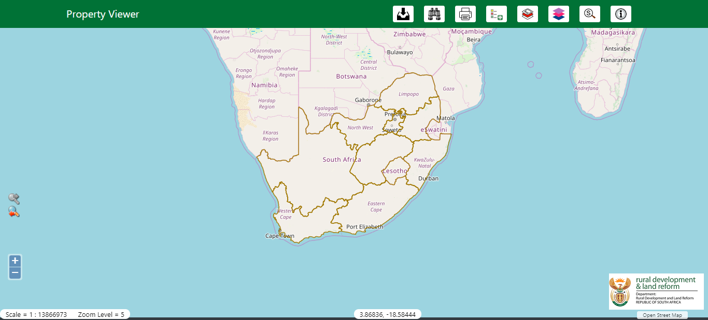
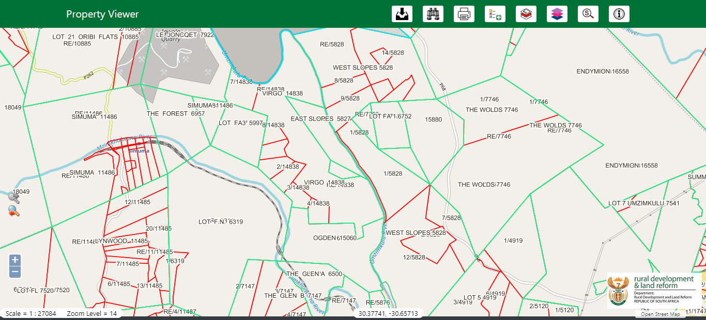

Main User Interface

When you begin to use the Map Viewer you must first get acquainted with the user interface.

https://www.giscloud.com/manual/map-viewer-manual/main-user-interface/







